Presentation of the project CIRCUMVECTIO Plus
Scientific responsible | Prof. Ing. Alessandro Farina
Link | https://interreg-maritime.eu/web/circumvetio-plus
Brief description of the project | The project concerns the development of a platform for the management and integration, along the entire logistic chain, of physical and documental flows at ports. The platform designed in CIRUMVECTIO Plus aims at improving the management of documents, especially customs ones, that require, for their production, a long time and the exchange of a large amount of information among port actors.  The project CIRCUMVECTIO Plus is indeed a “follow up” of the project CIRCUMVECTIO, that has concerned the design of the platform, especially the definition of the main functionalities: this task in particular was carried out by the University Centre of Logistic Systems.  In the CIRCUMVECTIO Plus project the Logistic Centre supports the enterprise that is developing the platform, Liguria Digitale, by suggesting in detail the functionalities to be implemented and the interaction between the platform and the ICT systems already existing and present in the territory.
Partner | Project leader:  - Liguria Region  Partner:  - University of Pisa – University Centre of Logistic Systems of Livorno  - Province of Livorno  - University of Genoa – CIELI  - Province of Sassari  - Chamber of Commerce of Bastia and North Corsica (FR)
Reference to the funding programme | 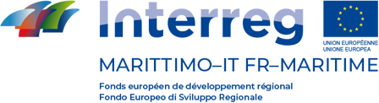  CIRCUMVECTIO Plus has been funded in the Interreg programme Italy – France Maritime 2014 – 2020, 5th Call, Axis 3 (Improvement of the connection of territories and of the sustainability of port activities).

